“Київський фаховий коледж зв’язку”

Циклова комісія комп’ютерної та програмної інженерії

**ЗВІТ ПО ВИКОНАННЮ**

**ЛАБОРАТОРНОЇ РОБОТИ №4**

з дисципліни: «Операційні системи»

**Тема: “Команди Linux для управління процесами”**

Виконав(ла/ли) студент(ка/и)

групи: КСМ-23а

The Awkward Turtles:

Когут Б.М., Михайленко О.О.,

Трощинський Я.П.

Перевірила викладач

Сушанова В.С.

Київ 2024

**Мета роботи:**

1. Отримання практичних навиків роботи з командною оболонкою Bash.
2. Знайомство з базовими командами для управління процесами.

*О.Михайленко:*

**1. What commands for monitoring the status of processes do you know. How to view their possible options?**

To monitor the state of processes in Linux and other Unix-like systems, various commands are used. Here are the main ones:

### 1. ps

The ps command displays information about running processes in the system.

#### Examples:

* **ps** – shows information about processes in the current terminal.
* **ps aux** – displays a list of all processes in the system.
* **ps -ef** – shows processes in a full list format.

### 2. top

The top command provides dynamic information about processes, allowing you to see how resource usage changes in real time.

#### Examples:

* **top** – launches process monitoring.

### 3. htop

This is a more user-friendly and visually enhanced version of top, displaying processes in colors and allowing the use of keys to manage processes.

#### Example:

* **htop** – launches the program for process monitoring.

### 4. kill

The kill command is used to terminate processes by their process ID (PID).

#### Examples:

* **kill PID** – terminates the process with the specified PID.
* **kill -9 PID** – forcibly terminates the process.

### 5. pgrep and pkill

* **pgrep** – searches for processes by name.
* **pkill** – terminates processes by name.

#### Examples:

* **pgrep firefox** – searches for the PID of the firefox process.
* **pkill firefox** – terminates all firefox processes.

**2. Can the *ps* command monitor the status of processes in real time?**

No, the ps command cannot track the state of processes in real time. It only provides a snapshot of the current state of processes at the moment it is executed. Each time you run ps, it shows the state of processes at that specific point in time.

For real-time process monitoring, commands like top or htop are more suitable, as they continuously update and display the status of processes in real time.

**3. By what parameters is it possible to sort processes in the *top* command? How to switch between them?**

### Common Sorting Parameters:

* **CPU usage**: Sorts processes by CPU usage (default).
* **Memory usage**: Sorts processes by memory usage.
* **Process ID (PID)**: Sorts processes by their process ID.
* **Running time**: Sorts processes by how long they have been running.
* **User ID (UID)**: Sorts processes by the user ID of the owner.
* **Priority**: Sorts processes by their priority.

### How to Switch Between Sorting Parameters:

While top is running, you can press specific keys to change the sorting:

* **P** – Sort by **CPU usage**.
* **M** – Sort by **memory usage**.
* **N** – Sort by **PID**.
* **T** – Sort by **running time**.
* **U** – Filter by a specific **user**.
* **<** – Move sorting criteria **left** (previous field).
* **>** – Move sorting criteria **right** (next field).

### Persistent Sorting:

If you want to make sorting changes permanent in top, you can save the configuration by pressing **Shift + W** while in top. This will store the current settings in the user's home directory.

**4. What commands to terminate processes do you know?**

### 1. kill

The kill command sends a signal to a process to terminate it, typically using the process ID (PID).

#### Examples:

* **kill PID** – Sends the default signal (SIGTERM), which asks the process to terminate gracefully.
* **kill -9 PID** – Sends the SIGKILL signal, which forcibly terminates the process (use this if the process does not respond to SIGTERM).

### 2. killall

The killall command terminates all processes by name.

#### Examples:

* **killall firefox** – Terminates all processes with the name firefox.
* **killall -9 firefox** – Forcibly terminates all firefox processes.

### 3. pkill

The pkill command allows you to kill processes by name or other attributes (such as user or terminal).

#### Examples:

* **pkill firefox** – Terminates all processes named firefox.
* **pkill -u username** – Terminates all processes belonging to a specific user.
* **pkill -9 firefox** – Forcibly terminates all firefox processes.

### 4. xkill

xkill is a graphical utility used to kill windows by clicking on them. It’s commonly used in desktop environments.

#### Example:

* **xkill** – After running this command, click on a window to terminate its process.

### 5. htop ****or**** top

In htop or top, you can interactively select and kill processes.

#### In htop:

* Use the **arrow keys** to select a process.
* Press **F9** or **k** to kill the selected process.
* Choose a signal to send (e.g., SIGTERM or SIGKILL).

#### In top:

* Press **k**, then enter the PID of the process you want to kill, followed by the signal (default is 15 for SIGTERM).

*Я.Трощинський:*

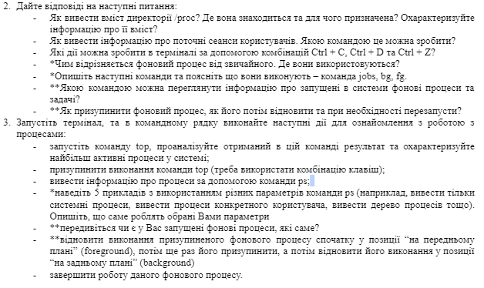

2. Answer the following questions:

* How to withdraw the content of the Directory /PROC? Where is it and what is intended for? Describe information about its content?
* How to display information about current user sessions. What team can you do?
* What steps can be taken in the terminal using Ctrl + C, Ctrl + D and Ctrl + Z?
* *How different is the background process from the usual one. Where are they used?
* *Describe the following commands and explain what they do - the Jobs, BG, FG command.
* ** With what command can you view the information about the background processes and tasks running into the systems?
* ** How to suspend the background process, how to restore it then and restart if necessary?

3.Run the terminal, and in the command line, perform the following steps to get acquainted with the work:

* Start the Top command, analyze the result in this command and describe the most active system processes;
* suspend the execution of the Top command (you need to use the key combination);
* deduce information about processes using PS command;
* *Give 5 examples using different PS command parameters (for example, display only system processes, deduce a specific user processes, deduce a process of processes, etc.). Describe what exactly the parameters you choose do
* ** Do you have advanced background processes, which ones?
* ** Restore the suspended background process first in the forecast position, then suspend it again, and then restore its execution in the background position
* complete the work of this background process.

2. - The directory /proc contains one subdirectory for each process running on the system it exists in the RAM. To see a content of the directory /proc I have written a command “ls /proc” and here what I got: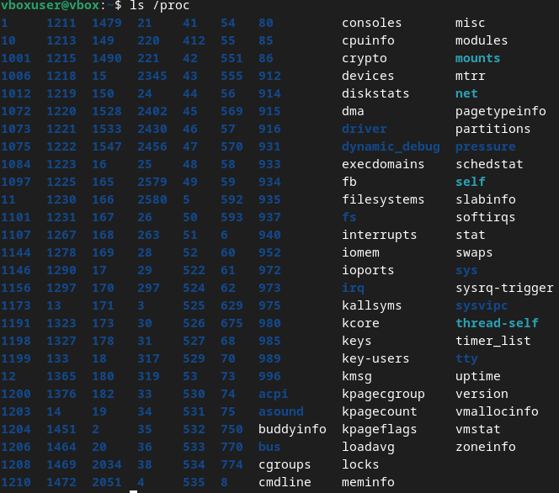

* To see what users are active right now I used a command “last -ap now”:

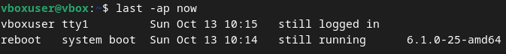

* If you use a Ctrl+C while having a command running, it will terminate.

If you use a Ctrl+Z while having a command running, it will suspend.

If you use a Ctrl+D after typing “sudo”, the terminal will be closed.

* Main difference between foreground and background process lies in who is activating it, if the activator is a user it is a foreground process, if it starts independently – it is the background one.

Background processes are used to do a operating systems.

* Using combination *command* &, you can make execution of this terminal command on the background, you can view progress and all of similar processes via using command “jobs”

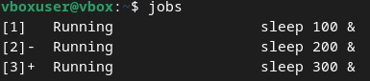

To move this processes from background to foreground(your terminal session) you can use command “fg %n” where n is number of job vice versa with using “bg %n”

* To see the list of background processes you need to type command “ps -e”.
* To suspend and re-enable any process using terminal you need to do a sequence of actions:

“top”/”pf -e”

find your process ID(PID)

“kill -19 *PID*” // your process is suspended and if you use a window of it, it will crush

“kill -18 *PID*” // process if normal now

3. - After using the command “top” I see a lot of things, from what I can see there about half of them are intuitively discoverable.

1. Total number of tasks
2. Total amount of active users
3. Process ID(PID)
4. Executing user of process
5. Priority
6. Name/directory of command

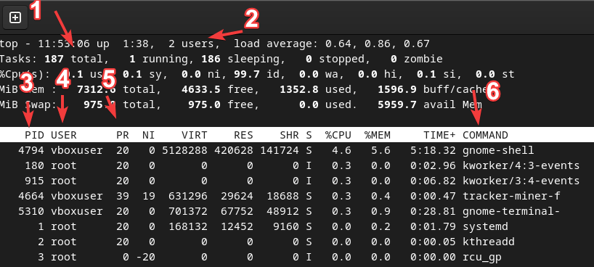

* To leave this table you need to tap “Q”, “Ctrl + Z”, or “Ctrl + C”.
* To see all root processes you need to type “ps -u root”

To see all user processes you need to type “ps -u *username*”

To see process tree you need to type either “ps -ef” or “pstree”

To get info about threads you need to type “ps -eLf”

To get info about needed process you need to type “ps -p *PID*”

* Using command “ps -e” I see a lot of background processes, roughly 500. I have processes of: system, gnome-shell, web content, gnome-terminal.
* 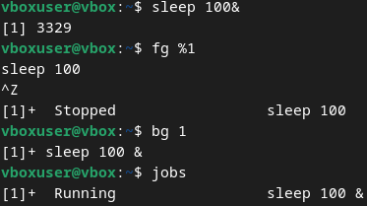
* To kill this job-process we can use 1 of 3 methods:

1. “fg %1” “Ctrl + C”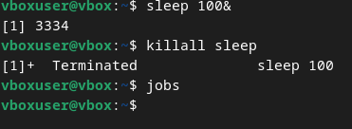
2. “kill -9 *PID”*
3. “killall *command*”

I used the third method:

*Б.Когут:*

**Control Questions:**

1. **What is the purpose of the /proc directory in Linux systems? What information does it store?**

The /proc directory is similar to the /dev directory because it contains not ordinary files but special files that provide information about running processes and the state of the kernel. The contents of the /proc directory are used by various utilities to obtain system information at runtime.

For example, if you want to check information about the processor in Linux, you can simply refer to the file `/proc/cpuinfo`. If you want to check the memory usage of your Linux system, look at the contents of the file `/proc/meminfo`.

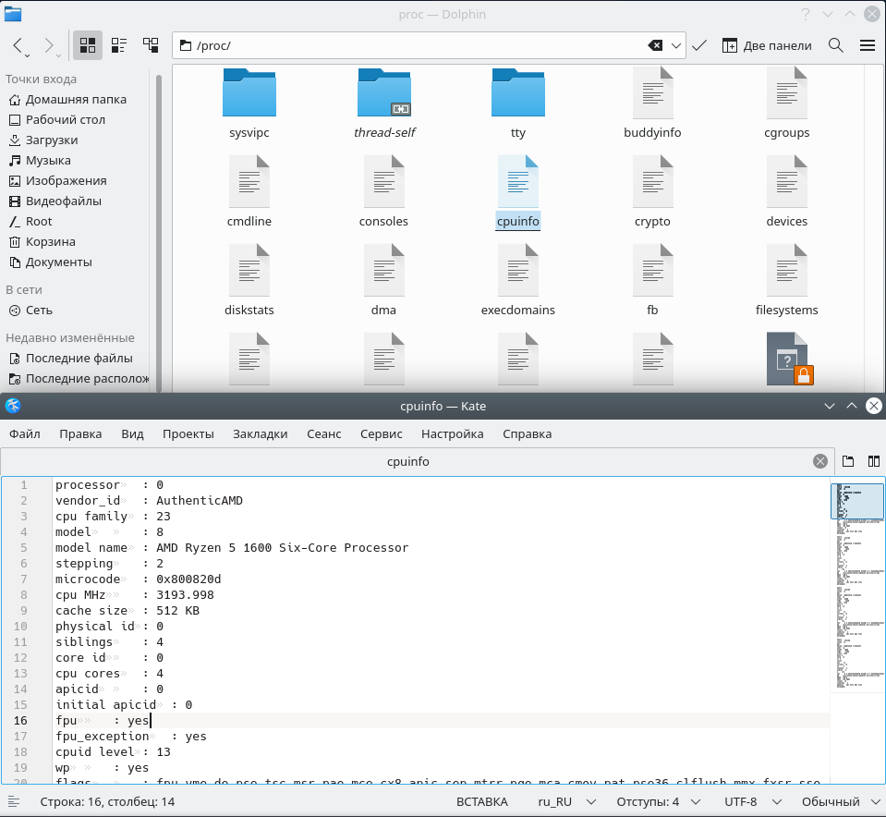

2. **How can you dynamically determine which of any three processes is currently using the most memory? What percentage of memory does it consume from the total?**

To see which processes are currently running, use the `ps` command, but it only shows the launched processes. You can also use the `ps` command with `head` and `grep` to filter the processes you want to display.

For example: `ps -e | grep <program name>`

The `top` command will show the currently running processes dynamically, regularly updating the process data.

3. **How to get the hierarchy of parent processes in Linux systems? Describe its structure.**

You can view the hierarchy of parent processes using the `pstree` command. It works like this: one process starts another process; the first process is called the parent process, and the second process is called the child process.

4. **What is the difference between the top and ps commands?**

The `ps` command shows the currently running processes, while the `top` command shows dynamically running processes.

5. **What additional features does htop implement compared to top?**

The main difference between `htop` and `top` is that `htop` shows the same information as `top` but presents it in a more user-friendly interface, filtering them and providing more detailed information about the processes.

6. **Describe the components of your mobile OS for monitoring running processes in the system.**

Typically, in a mobile operating system, the following are used for monitoring running processes:

Task Manager: Displays all active applications and processes.

OS Kernel: Controls low-level process management, ensuring scheduling and resource management.

System Monitor: Tools that provide detailed information about resource usage, such as CPU, memory, and network connections.

7. **Does your mobile OS support terminal management of process operations? Describe how.**

Android supports terminal access through the ADB command interface, allowing users to view running processes, terminate them, or change their priorities. For example, the `ps` command can be used to view processes, or `kill` can be used to terminate them.

8. **Is it possible to install third-party software tools that allow you to manage and monitor the operation of processes on your mobile phone? Briefly describe them.**

Yes, it is possible on Android to install third-party applications for process monitoring, such as System Monitor, Termux, and Greenify.

**Conclusion(висновок)**

During this lab, we explored the process management commands available in Linux, gaining hands-on experience with the *top, ps, jobs, bg, fg,* and other relevant commands. By utilizing these tools, we learned how to monitor system processes in real time, sort them by various criteria, and control their execution. Additionally, we developed skills in managing both foreground and background processes, understanding their behavior and how to handle them effectively. This knowledge is essential for efficient system administration and optimizing resource usage.